**ABSTRACT**

A voltage protection system is a device which is used to sense inappropriate voltage levels and correct them to produce a reasonably stable output where the load is connected. Here we will study the design of a simple automatic AC voltage protection system which can be used for the above purpose. In this circuit, active and passive devices, such as diodes, transformer, resistor, capacitor, relay, IC etc. have been used. One step down transformer and one step up transformer have also been used in this work. In case the line voltage crosses a predetermined threshold, the comparator detects it and its output immediately goes high, switching ON the transistor and the relay for the desired actions. The relay contacts are appropriately integrated to the transformer taps for executing the above actions as per the commands given by the microcontroller output. The designed circuit operates successfully and the results obtained are satisfactory. When installed, the relay trips whenever the input voltage crosses 230 volts, bringing the output to 218 volts and keeps it until the voltage reaches higher levels. When the voltage drops back to 225, the relay gets de-energized pulling the voltage to 238 volts and maintains the difference as the voltage further goes down. The above action keeps the output to the appliance well between 200 to 250 volts with fluctuations ranging from 180 to 265 volts.

# ACKNOWLEDGEMENT

First start with great thank to almighty, we take this opportunity to express our profound gratitude and deep regards to our guide for his exemplary guidance, monitoring and constant encouragement throughout the course of this project. I can’t say thank you enough for his tremendous support and help. I feel motivated and encouraged every time we attend his meeting. Without his encouragement and guidance this project would not have materialized.

We sincerely thank the respected teachers and faculty members of Northern University Bangladesh as they have tremendous contribution behind our progress.

Last but not least we wish to avail ourselves of this opportunity, express a sense of gratitude and love to our friends and our beloved parents for their manual support, strength and help and for everything.

Authors

November 2017

**TABEL OF CONTENTS Page No.**

## Chapter 1: Introduction & Overview………………………………………… 1

**1.1 Introduction………………………………………………………... 1**

**1.2 Block Diagram ……………………………………………………. 1**

**1.3 Overview ………………………………….……………………… 2 Chapter 2: Description of Equipments ……………………….……………… 3**

**2.1 Required Component……………………………………………… 3**

**2.2 Transformer ………………………………………………………. 4**

**2.3 Capacitor ………………………………………………………….. 8**

**2.4 Resistor …………………………………………………………….. 15**

**2.5 Potentiometer………………………………………………………. 18**

**2.6 Diode ………………………………………………………………. 23**

**2.7 Zener Diode………………………………………………………… 26**

**2.8 Op-Amp (LM741)…………………………………………………. 27**

**2.9 Transistor………………………………………………………….. 29**

**2.10 Relay……………………………………………………………….. 33 Chapter 3: Circuit and Operation …………………………………………… 37**

**3.1 How the Circuit Functions………………………………………… 37**

**3.2 Circuit Diagram …………………………………………………… 38**

**3.3 Circuit Design & Implementation ………………………………… 39 Chapter 4: Discussion and Conclusion ………………………………………. 40**

**4.1 Utilities ………………………………………………………………. 40**

### 4.2 Limitation…………………………………………………………… 40

**4.3 Conclusion…………………………………………………………… 41 References …………………………………………………………….…….......... 42**

# Chapter 1 Introduction & Overview

**1.1 Introduction**

A voltage protection system is a device which is used to sense inappropriate voltage levels and correct them to produce a reasonably stable output at the output where the load is connected. Which is fabricated using transistor and other discrete components. It can be used to protect loads such as TV, Refrigerator and VCR from undesirable over and under line voltages, as well as surges caused due to sudden failure/resumption of mains power supply. This circuit can be directly as standalone circuit between the main supply and the load, or it may be inserted between an existing automatic/manual protection system and the load. In case the mains voltage crosses a predetermined threshold, the ICs non inverting detects it and its output immediately goes high, switching ON the transistor and the relay for the desired actions.

The relay, which is a DPDT type of relay, has its contacts wired up to a transformer, which is an ordinary transformer modified to perform the function of a protection system transformer.

So if the input AC voltage tends to increase a set threshold value, the transformer deducts some voltage and tries to stop the voltage from reaching dangerous levels and vice versa during low voltage situations.

**1.2Block Diagram :**

AC Input

Power

Supply

Rectifier

& Filter

Amplifi

e

r

Relay

Output

## Fig: Block diagram of Voltage Protection system

**Operation:**

220V ac input supply from supply line and flow the ac voltage of rectifier. Rectifier chance the voltage ac to dc and capacitor chance the filtering dc. Operational amplifier or comparator compare the ac supply voltage. Relay is an Electrical switchingdevice.Its Normally-open (NO) contacts connect the circuit when the relay is activated the circuit is disconnected when the relay is inactive. Normally-closed (NC) contacts disconnect the circuit when the relay is activated; the circuit is connected when the relay is inactive. Change-over (CO), or double-throw (DT), contacts control two circuits: one normally-open contact and one normally-closed contact with a common terminal. Output voltmeter show the stable voltage.

**1.3 Overview**

A voltage protection system is a device which is used to sense inappropriate voltage levels and correct them to produce a reasonably stable output at the output where the load is connected. The power line fluctuations and cut-offs cause damages to electrical appliances connected to the line. It is more serious in the case of domestic appliances like Fridge and Television. If a fridge is operated on low voltage, excessive current flows through the motor, which heats up, and get damaged.

The high/low voltage protection circuit with time delay presented here is a low cost and reliable circuit for protecting such equipments from damages. Whenever the power line is switched on it gets connected to the appliance only after a delay of a fixed time. If the power down time (time for which the voltage is beyond limits) is less than the delay time, the power resumes after the delay: If it is equal or more, then the power resumes directly.

This circuit has been designed, built and evaluated by me to use as a protector for my home refrigerator. This is designed around readily available semi-conductor devices such as standard bipolar medium power NPN transistor (BC547), an 8-pin type 741 op-amp IC and DPDT relay. Its salient feature is that no relay hunting is employed. This draw back is commonly found in the proctors available in the market.

The complete circuit is consisting of various stages. They are: - Dual rail power supply, Reference voltage source, Voltage comparators for hi/low, Time delay stage and Relay driver stage. Lets now look at the step-by-step design details

# Chapter 2 Description of Equipments

**2.1 Required Component**:

|  |  |
| --- | --- |
| Resistor R1, R3, R7 | 10KΩ |
| Resistor R2, R4 | 100KΩ |
| Resistor R5 | 4.7KΩ |
| Resistor R6 | 10Ω |
| Variable Resistor | 1KΩ |
| Capacitor C1 | 470uF |
| Capacitor C2 | 47uF |
| Capacitor C3, C4 | 22pF |
| Capacitor C5 | 0.1uF |
| Diode D1 & D2 | 1N 4007 |
| Zener Diode | 5.1 V/ 400mW |
| Transformer TR1 | 0V - 12 V , 500mA |
| Transistor | BC 547 |
| Relay | 6V, 200Ω. |
| LED | Red (1) |
| LCD | 1602A |
| Crystal | 20MHz |
| AC Lamp | 220V, 15W |
| Switch | ON/OFF (3piece) |
| 5V Regulator | LM7805 |
| Microcontroller | PIC16F72 |
| Buzzer | 5VDC |

**2.2 Transformer**:

Basic principles a **transformer** is an electrical device that transfers energy between two or more circuits through [electromagnetic induction.](http://en.wikipedia.org/wiki/Electromagnetic_induction)

A varying current in the transformer's primary winding creates a varying [magnetic flux](http://en.wikipedia.org/wiki/Magnetic_flux) in the core and a varying magnetic field impinging on the secondary winding. This varying [magnetic field](http://en.wikipedia.org/wiki/Magnetic_field) at the secondary induces a varying [electromotive force](http://en.wikipedia.org/wiki/Electromotive_force) (emf) or voltage in the secondary winding. Making use of [Faraday's Law](http://en.wikipedia.org/wiki/Faraday%27s_law_of_induction) in conjunction with high [magnetic permeability](http://en.wikipedia.org/wiki/Permeability_%28electromagnetism%29) core properties, transformers can thus be designed to efficiently change [AC](http://en.wikipedia.org/wiki/Alternating_current) voltages from one voltage level to another within power networks. Transformers have become essential for the AC [transmission,](http://en.wikipedia.org/wiki/Electric_power_transmission) [distribution,](http://en.wikipedia.org/wiki/Electric_power_distribution) and utilization of electrical energy.

**Ideal transformer equations:**

**By Faraday's law of induction**

. . . (1)

. . .(2)

Combining ratio of (1) & (2)

Turns ratio

. . . (3) where

for step

-

down transformers, a > 1

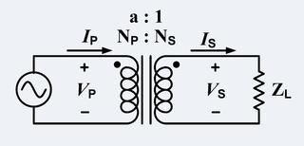

for step

-

up transformers, a < 1

By law of

[y](http://en.wikipedia.org/wiki/Conservation_of_Energy)

[Conservation of Energ](http://en.wikipedia.org/wiki/Conservation_of_Energy)

[,](http://en.wikipedia.org/wiki/Conservation_of_Energy)

[apparen](http://en.wikipedia.org/wiki/Apparent_power)

[t](http://en.wikipedia.org/wiki/Apparent_power)

[,](http://en.wikipedia.org/wiki/Apparent_power)

[rea](http://en.wikipedia.org/wiki/Real_power)

[l](http://en.wikipedia.org/wiki/Real_power)

and

[reactiv](http://en.wikipedia.org/wiki/Reactive_power)

[e](http://en.wikipedia.org/wiki/Reactive_power)

power are each conserved in the

input and output

. . (4)

Combining (3) & (4) with this endnote

[]](http://en.wikipedia.org/wiki/Transformer#cite_note-6)

[[](http://en.wikipedia.org/wiki/Transformer#cite_note-6)

[b](http://en.wikipedia.org/wiki/Transformer#cite_note-6)

yields the ideal transformer

[identit](http://en.wikipedia.org/wiki/Identity_function)

[y](http://en.wikipedia.org/wiki/Identity_function)

. . . (5)

By

[w](http://en.wikipedia.org/wiki/Ohm%27s_Law)

[Ohm's La](http://en.wikipedia.org/wiki/Ohm%27s_Law)

and ideal transformer identity

. . .(6)

Apparent load impedance Z'

L

(

Z

L

referred to the primary)

. . .(7)

Ideal transformer and induction law

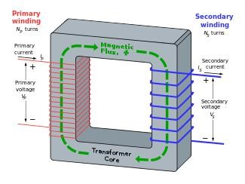

It is very common, for simplification or approximation purposes, to analyze the transformer as an ideal transformer model as represented in the two images. An ideal transformer is a theoretical, [linear](http://en.wikipedia.org/wiki/Linearity) transformer that is lossless and perfectly [coupled;](http://en.wikipedia.org/wiki/Magnetic_coupling) that is, there are no [energy losses](http://en.wikipedia.org/wiki/Transformer#Energy_Losses) and [flux](http://en.wikipedia.org/wiki/Flux) is completely confined within the [magnetic core.](http://en.wikipedia.org/wiki/Magnetic_core) Perfect coupling implies infinitely high core [magnetic permeability](http://en.wikipedia.org/wiki/Permeability_%28electromagnetism%29) and winding inductances and zero net [magnetomotive force.](http://en.wikipedia.org/wiki/Magnetomotive_force)

A varying current in the transformer's primary winding creates a varying magnetic flux in the core and a varying magnetic field impinging on the secondary winding. This varying magnetic field at the secondary induces a varying electromotive force (EMF) or voltage in the secondary winding. The primary and secondary windings are wrapped around a core of infinitely high magnetic permeability[[e]](http://en.wikipedia.org/wiki/Transformer#cite_note-11) so that all of the magnetic flux passes through both the primary and secondary windings. With [voltage source](http://en.wikipedia.org/wiki/Voltage_source) connected to the primary winding and load [impedance](http://en.wikipedia.org/wiki/Electrical_impedance) connected to the secondary winding, the transformer currents flow in the indicated directions.

**Center Taps Transformer:**

In electronics, a center tap is connection made to a point halfway along a winding of a Transformer or inducer, or along the element of a resistor or a potentiometer. Taps are Sometimes used on inductors for the coupling of signals, and may not necessarily be at the halfway point , but rather, closer to one end. A common application of this is in the Hartley oscillator. Inductors with taps also permit the transformation of the amplitude of alternating current (AC) voltages for the purpose of power conversion, in which case, they are referred to as autotransformers, since there is only one winding. An example of an autotransformers is an automobile ignition coil. Potentiometer tapping provides one or more connections along the device’s element, along with the usual connections at each of the two ends of the element, and the slider connection. Potentiometer taps allow for circuit functions that would otherwise not be available with the usual construction of just the two end connections and one slider connection.

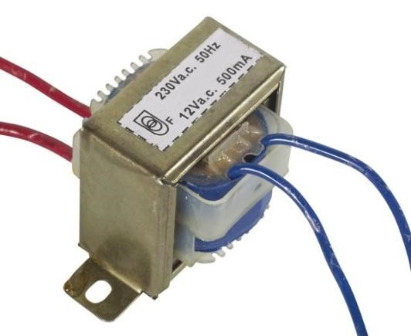

## Fig: 12V ac. 500mA Center- tap Transformer

**Step-Up Transformer:**

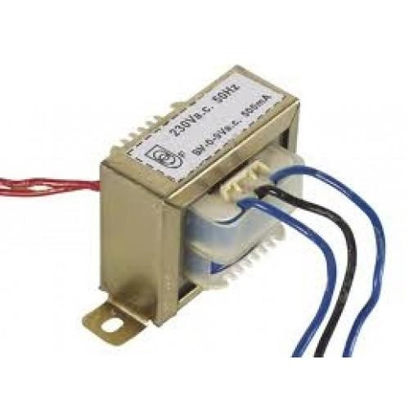

## Fig: Step-up Transformer

**2.3 Capacitor:**

[**Electronic symbol**](http://en.wikipedia.org/wiki/Electronic_symbol)

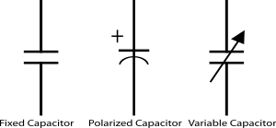

A **capacitor** (originally known as a **condenser**) is a [passive](http://en.wikipedia.org/wiki/Passivity_%28engineering%29) [two-terminal](http://en.wikipedia.org/wiki/Terminal_%28electronics%29) [electrical component](http://en.wikipedia.org/wiki/Electronic_component) used to store [energy](http://en.wikipedia.org/wiki/Energy) [electro statically](http://en.wikipedia.org/wiki/Electrostatic) in an [electric field.](http://en.wikipedia.org/wiki/Electric_field) The forms of practical capacitors vary widely, but all contain at least two [electrical conductors](http://en.wikipedia.org/wiki/Electrical_conductor) (plates) separated by a [dielectric](http://en.wikipedia.org/wiki/Dielectric) (i.e. [insulator)](http://en.wikipedia.org/wiki/Insulator_%28electricity%29). The conductors can be thin films, foils or sintered beads of metal or conductive electrolyte, etc. The "non-conducting" dielectric acts to increase the capacitor's charge capacity. A dielectric can be glass, ceramic, plastic film, air, vacuum, paper, mica, oxide layer etc. Capacitors are widely used as parts of [electrical circuits](http://en.wikipedia.org/wiki/Electrical_circuit) in many common electrical devices. Unlike a [resistor,](http://en.wikipedia.org/wiki/Resistor) an ideal capacitor does not dissipate energy. Instead, a capacitor stores [energy](http://en.wikipedia.org/wiki/Energy) in the form of an [electrostatic field](http://en.wikipedia.org/wiki/Electric_field) between its plates.

**Theory of operation:**

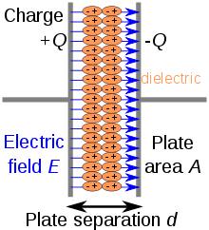

Charge separation in a parallel-plate capacitor causes an internal electric field. A dielectric (orange) reduces the field and increases the capacitance.

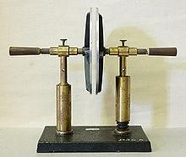

A simple demonstration of a parallel-plate capacitor

A capacitor consists of two [conductors](http://en.wikipedia.org/wiki/Electrical_conductor) separated by a non-conductive region. The nonconductive region is called the [dielectric.](http://en.wikipedia.org/wiki/Dielectric) In simpler terms, the dielectric is just an [electrical insulator.](http://en.wikipedia.org/wiki/Insulator_%28electrical%29) Examples of dielectric media are glass, air, paper, [vacuum,](http://en.wikipedia.org/wiki/Vacuum) and even a [semiconductor](http://en.wikipedia.org/wiki/Semiconductor) [depletion region](http://en.wikipedia.org/wiki/Depletion_region) chemically identical to the conductors. A capacitor is assumed to be selfcontained and isolated, with no net [electric charge](http://en.wikipedia.org/wiki/Electric_charge) and no influence from any external electric field. The conductors thus hold equal and opposite charges on their facing surfaces, and the dielectric develops an electric field. In [SI](http://en.wikipedia.org/wiki/SI) units, a capacitance of one [farad](http://en.wikipedia.org/wiki/Farad) means that one [coulomb](http://en.wikipedia.org/wiki/Coulomb) of charge on each conductor causes a voltage of one [volt](http://en.wikipedia.org/wiki/Volt) across the device.

An ideal capacitor is wholly characterized by a constant [capacitance](http://en.wikipedia.org/wiki/Capacitance) *C*, defined as the ratio of charge ±*Q* on each conductor to the voltage *V* between them:



Because the conductors (or plates) are close together, the opposite charges on the conductors attract one another due to their electric fields, allowing the capacitor to store more charge for a given voltage than if the conductors were separated, giving the capacitor a large capacitance. Sometimes charge build-up affects the capacitor mechanically, causing its capacitance to vary.

In this case, capacitance is defined in terms of incremental changes:



**Parallel-plate model:**

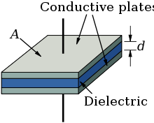

## Dielectric is placed between two conducting plates, each of area A and with a separation of d

The simplest capacitor consists of two parallel conductive plates separated by a dielectric (such as air) with [permittivity](http://en.wikipedia.org/wiki/Permittivity) ε . The model may also be used to make qualitative predictions for other device geometries. The plates are considered to extend uniformly over an area A and a charge density ±ρ = ±Q/A exists on their surface. Assuming that the width of the plates is much greater than their separation d, the electric field near the centre of the device will be uniform with the magnitude E = ρ/ε. The voltage is defined as the [line integral](http://en.wikipedia.org/wiki/Line_integral) of the electric field between the plates



Solving this for C = Q/V reveals that capacitance increases with area of the plates, and decreases as separation between plates increases.



The capacitance is therefore greatest in devices made from materials with a high permittivity, large plate area, and small distance between plates. A parallel plate capacitor can only store a finite amount of energy before [dielectric breakdown](http://en.wikipedia.org/wiki/Dielectric_breakdown) occurs. The capacitor's dielectric material has a [dielectric strength](http://en.wikipedia.org/wiki/Dielectric_strength) Ud which sets the [capacitor's breakdown voltage](http://en.wikipedia.org/wiki/Capacitor#Breakdown_voltage) at V = Vbd = Udd. The maximum energy that the capacitor can store is therefore



We see that the maximum energy is a function of dielectric volume, [permittivity,](http://en.wikipedia.org/wiki/Permittivity) and [dielectric strength](http://en.wikipedia.org/wiki/Dielectric_strength) per distance. So increasing the plate area while decreasing the separation between the plates while maintaining the same volume has no change on the amount of energy the capacitor can store. Care must be taken when increasing the plate separation so that the above assumption of the distance between plates being much smaller than the area of the plates is still valid for these equations to be accurate. In addition, these equations assume that the electric field is entirely concentrated in the dielectric between the plates. In reality there are fringing fields outside the dielectric, for example between the sides of the capacitor plates, which will increase the effective capacitance of the capacitor. This could be seen as a form of [parasitic capacitance.](http://en.wikipedia.org/wiki/Parasitic_capacitance) For some simple capacitor geometries this additional capacitance term can be calculated analytically.[17]It becomes negligibly small when the ratio of plate area to separation is large.

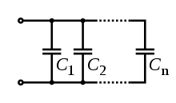

Several capacitors in parallel

**Networks:**

See also: [Series and parallel circuits](http://en.wikipedia.org/wiki/Series_and_parallel_circuits) for capacitors in parallel Capacitors in a parallel configuration each have the same applied voltage. Their capacitances add up. Charge is apportioned among them by size. Using the schematic diagram to visualize parallel plates, it is apparent that each capacitor contributes to the total surface area.



For capacitors in series



Several capacitors in series

Connected in series, the schematic diagram reveals that the separation distance, not the plate area, adds up. The capacitors each store instantaneous charge build-up equal to that of every other capacitor in the series. The total voltage difference from end to end is apportioned to each capacitor according to the inverse of its capacitance. The entire series acts as a capacitor smaller than any of its components.



Capacitors are combined in series to achieve a higher working voltage, for example for smoothing a high voltage power supply. The voltage ratings, which are based on plate separation, add up, if capacitance and leakage currents for each capacitor are identical. In such an application, on occasion, series strings are connected in parallel, forming a matrix. The goal is to maximize the energy storage of the network without overloading any capacitor. For high-energy storage with capacitors in series, some safety considerations must be applied to ensure one capacitor failing and leaking current will not apply too much voltage to the other series capacitors. Series connection is also sometimes used to adapt polarized [electrolytic capacitors](http://en.wikipedia.org/wiki/Electrolytic_capacitor) for bipolar AC use. See [electrolytic capacitor designing for reverse bias.](http://en.wikipedia.org/wiki/Electrolytic_capacitor#Designing_for_reverse_bias)

**Voltage distribution in parallel-to-series networks :**

To model the distribution of voltages from a single charged capacitor connected in parallel to a chain of capacitors in series

:

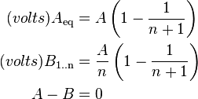

**Note:** This is only correct if all capacitance values are equal.

The power transferred in this arrangement is:



**Structure:**

Capacitor packages: [SMD](http://en.wikipedia.org/wiki/Surface-mount_technology) ceramic at top left; SMD tantalum at bottom left; [through-hole](http://en.wikipedia.org/wiki/Through-hole) tantalum at top right; through-hole electrolytic at bottom right. Major scale divisions are cm.

The arrangement of plates and dielectric has many variations depending on the desired ratings of the capacitor. For small values of capacitance (microfarads and less), ceramic disks use metallic coatings, with wire leads bonded to the coating. Larger values can be made by multiple stacks of plates and disks. Larger value capacitors usually use a metal foil or metal film layer deposited on the surface of a dielectric film to make the plates, and a dielectric film of impregnated [paper](http://en.wikipedia.org/wiki/Electrical_insulation_paper) or plastic – these are rolled up to save space. To reduce the series resistance and inductance for long plates, the plates and dielectric are staggered so that connection is made at the common edge of the rolled-up plates, not at the ends of the foil or metalized film strips that comprise the plates.

The assembly is encased to prevent moisture entering the dielectric – early radio equipment used a cardboard tube sealed with wax. Modern paper or film dielectric capacitors are dipped in a hard thermoplastic. Large capacitors for high-voltage use may have the roll form compressed to fit into a rectangular metal case, with bolted terminals and bushings for connections. The dielectric in larger capacitors is often impregnated with a liquid to improve its properties.

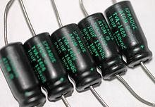

Several axial-lead [electrolytic capacitors](http://en.wikipedia.org/wiki/Electrolytic_capacitor)

Capacitors may have their connecting leads arranged in many configurations, for example axially or radially. "Axial" means that the leads are on a common axis, typically the axis of the capacitor's cylindrical body – the leads extend from opposite ends. Radial leads might more accurately be referred to as tandem; they are rarely actually aligned along radii of the body's circle, so the term is inexact, although universal. The leads (until bent) are usually in planes parallel to that of the flat body of the capacitor, and extend in the same direction; they are often parallel as manufactured.

Small, cheap discoidal [ceramic capacitors](http://en.wikipedia.org/wiki/Ceramic_capacitor) have existed since the 1930s, and remain in widespread use. Since the 1980s, [surface mount](http://en.wikipedia.org/wiki/Surface_mount) packages for capacitors have been widely used. These packages are extremely small and lack connecting leads, allowing them to be soldered directly onto the surface of [printed circuit boards.](http://en.wikipedia.org/wiki/Printed_circuit_boards) Surface mount components avoid undesirable high-frequency effects due to the leads and simplify automated assembly, although manual handling is made difficult due to their small size.

Mechanically controlled variable capacitors allow the plate spacing to be adjusted, for example by rotating or sliding a set of movable plates into alignment with a set of stationary plates. Low cost variable capacitors squeeze together alternating layers of aluminum and plastic with a [screw.](http://en.wikipedia.org/wiki/Trimmer_%28electronics%29) Electrical control of capacitance is achievable with [varactors](http://en.wikipedia.org/wiki/Varactor) (or varicaps), which are [reverse-biased](http://en.wikipedia.org/wiki/Reverse-biased) [semiconductor diodes](http://en.wikipedia.org/wiki/Semiconductor_diode) whose depletion region width varies with applied voltage.

They are used in [phase-locked loops,](http://en.wikipedia.org/wiki/Phase_locked_loop) amongst other applications.

**Applications:**

1. Energy storage
2. Power factor correction
3. Suppression and coupling
4. High-pass and low-pass filters
5. Motor starters
6. Hazards and safety

**2.4 Resistor:**

A **resistor** is a [passive](http://en.wikipedia.org/wiki/Passivity_%28engineering%29) [two-terminal](http://en.wikipedia.org/wiki/Terminal_%28electronics%29) [electrical component](http://en.wikipedia.org/wiki/Electronic_component) that implements [electrical resistance](http://en.wikipedia.org/wiki/Electrical_resistance) as a circuit element. Resistors act to reduce current flow, and, at the same time, act to lower voltage levels within circuits. In electronic circuits resistors are used to limit current flow, to adjust signal levels, [bias](http://en.wikipedia.org/wiki/Bias) active elements, terminate [transmission lines](http://en.wikipedia.org/wiki/Transmission_line) among other uses. Highpower resistors that can dissipate many [watts](http://en.wikipedia.org/wiki/Watt) of electrical power as heat may be used as part of motor controls, in power distribution systems, or as test loads for [generators.](http://en.wikipedia.org/wiki/Electric_generator) Resistors may have fixed resistances that only change a little with temperature, time or operating voltage. Variable resistors can be used to adjust circuit elements (such as a volume control or a lamp dimmer), or as sensing devices for heat, light, humidity, force, or chemical activity. Resistors are common elements of [electrical networks](http://en.wikipedia.org/wiki/Electrical_network) and [electronic circuits](http://en.wikipedia.org/wiki/Electronic_circuit) and are ubiquitous in [electronic equipment.](http://en.wikipedia.org/wiki/Electronics) Practical resistors as discrete components can be composed of various compounds and forms. Resistors are also implemented within [integrated circuits.](http://en.wikipedia.org/wiki/Integrated_circuits) The electrical function of a resistor is specified by its resistance: common commercial resistors are manufactured over a range of more than nine [orders of magnitude.](http://en.wikipedia.org/wiki/Orders_of_magnitude) The nominal value of the resistance will fall within a [manufacturing tolerance.](http://en.wikipedia.org/wiki/Engineering_tolerance#Electrical_component_tolerance)

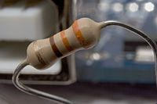

A typical axial-lead resistor

## [Electronic symbol](http://en.wikipedia.org/wiki/Electronic_symbol)



**Electronic symbols and notation:**

* 

(a) resistor, (b) rheostat (variable resistor), and (c) potentiometer

* 

**Theory of operation:**

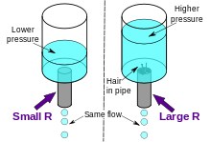

The [hydraulic analogy](http://en.wikipedia.org/wiki/Hydraulic_analogy) compares electric current flowing through circuits to water flowing through pipes. When a pipe (left) is filled with hair (right), it takes a larger pressure to achieve the same flow of water. Pushing electric current through a large resistance is like pushing water through a pipe clogged with hair: It requires a larger push ([voltage drop)](http://en.wikipedia.org/wiki/Voltage_drop) to drive the same flow [(electric current)](http://en.wikipedia.org/wiki/Electric_current).

**Ohm's law:**

The behavior of an ideal resistor is dictated by the relationship specified by [Ohm's law:](http://en.wikipedia.org/wiki/Ohm%27s_law)



Ohm's law states that the voltage (V) across a resistor is proportional to the current (I), where the constant of proportionality is the resistance (R). For example, if a 300 [ohm](http://en.wikipedia.org/wiki/Ohm) resistor is attached across the terminals of a 12 volt battery, then a current of 12 / 300 = 0.04 [amperes](http://en.wikipedia.org/wiki/Ampere) flows through that resistor.

Practical resistors also have some [inductance](http://en.wikipedia.org/wiki/Inductance) and [capacitance](http://en.wikipedia.org/wiki/Capacitance) which will also affect the relation between voltage and current in [alternating current](http://en.wikipedia.org/wiki/Alternating_current) circuits.

The [ohm](http://en.wikipedia.org/wiki/Ohm_%28unit%29) (symbol: [Ω)](http://en.wikipedia.org/wiki/%CE%A9) is the [SI](http://en.wikipedia.org/wiki/SI) unit of [electrical resistance,](http://en.wikipedia.org/wiki/Electrical_resistance) named after [Georg Simon Ohm.](http://en.wikipedia.org/wiki/Georg_Simon_Ohm) An ohm is equivalent to a [volt](http://en.wikipedia.org/wiki/Volt) per [ampere.](http://en.wikipedia.org/wiki/Ampere) Since resistors are specified and manufactured over a very large range of values, the derived units of milliohm (1 mΩ = 10−3 Ω), kilo ohm (1 kΩ = 103 Ω), and mega ohm (1 MΩ = 106 Ω) are also in common usage.

**Series and parallel resistors:**

The total resistance of resistors connected in series is the sum of their individual resistance values.

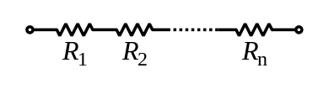



The total resistance of resistors connected in parallel is the reciprocal of the sum of the reciprocals of the individual resistors.

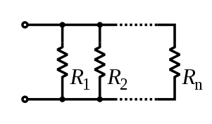

So, for example, a 10 ohm resistor connected in parallel with a 5 ohm resistor and a 15 ohm resistor will produce the inverse of 1/10+1/5+1/15 ohms of resistance, or 1/(.1+.2+.067)=2.725 ohms. A resistor network that is a combination of parallel and series connections can be broken up into smaller parts that are either one or the other. Some complex networks of resistors cannot be resolved in this manner, requiring more sophisticated circuit analysis. Generally, the [Y-Δ transform,](http://en.wikipedia.org/wiki/Y-%CE%94_transform) or [matrix methods](http://en.wikipedia.org/wiki/Equivalent_impedance_transforms#2-terminal.2C_n-element.2C_3-element-kind_networks) can be used to solve such problems.

**Power dissipation:**

At any instant of time, the power P consumed by a resistor of resistance R (ohms) is calculated as:



where V (volts) is the voltage across the resistor and I (amps) is the [current](http://en.wikipedia.org/wiki/Ampere) flowing through it. Using Ohm's law, the two other forms can be derived. This power is converted into heat which must be dissipated by the resistor's package before its temperature rises excessively.

**Lead arrangements:**

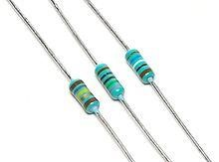

2.5 **Potentiometer:**

A **potentiometer** informally a **pot**, is a three[-terminal](http://en.wikipedia.org/wiki/Terminal_%28electronics%29) [resistor](http://en.wikipedia.org/wiki/Resistor) with a sliding or rotating contact that forms an adjustable [voltage divider.](http://en.wikipedia.org/wiki/Voltage_divider) If only two terminals are used, one end and the wiper, it acts as a **variable resistor** or **rheostat**. A [potentiometer measuring instrument](http://en.wikipedia.org/wiki/Potentiometer_%28measuring_instrument%29) is essentially a voltage divider used for measuring [electric potential](http://en.wikipedia.org/wiki/Electric_potential) (voltage); the component is an implementation of the same principle, hence its name. Potentiometers are commonly used to control electrical devices such as volume controls on audio equipment. Potentiometers operated by a mechanism can be used as position [transducers,](http://en.wikipedia.org/wiki/Transducer) for example, in a [joystick.](http://en.wikipedia.org/wiki/Joystick) Potentiometers are rarely used to directly control significant power (more than a [watt)](http://en.wikipedia.org/wiki/Watt), since the power dissipated in the potentiometer would be comparable to the power in the controlled load.

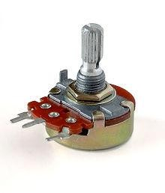

## Fig: A typical single-turn potentiometer

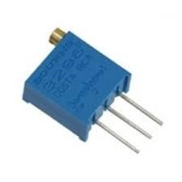

[**Electronic symbol:**](http://en.wikipedia.org/wiki/Electronic_symbol)

(International)



(US)

**Potentiometer construction:**

Potentiometers comprise a resistive element, a sliding contact (wiper) that moves along the element, making good electrical contact with one part of it, electrical terminals at each end of the element, a mechanism that moves the wiper from one end to the other, and a housing containing the element and wiper.

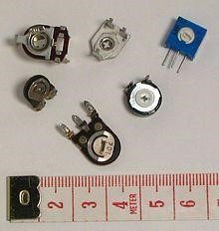

Many inexpensive potentiometers are constructed with a resistive element formed into an arc of a circle usually a little less than a full turn and a wiper sliding on this element when rotated, making electrical contact. The resistive element, with a terminal at each end, is flat or angled. The wiper is connected to a third terminal, usually between the other two. On panel potentiometers, the wiper is usually the center terminal of three. For single-turn potentiometers, this wiper typically travels just under one revolution around the contact. The only point of ingress for contamination is the narrow space between the shaft and the housing it rotates in.

Another type is the linear slider potentiometer, which has a wiper which slides along a linear element instead of rotating. Contamination can potentially enter anywhere along the slot the slider moves in, making effective sealing more difficult and compromising long-term reliability. An advantage of the slider potentiometer is that the slider position gives a visual indication of its setting. While the setting of a rotary potentiometer can be seen by the position of a marking on the knob, an array of sliders can give a visual impression of, for example, the effect of a multiband [equalizer.](http://en.wikipedia.org/wiki/Equalisation)

**Theory of operation:**

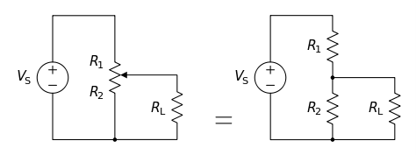

**A potentiometer with a resistive load, showing equivalent fixed resistors for clarity.**

The potentiometer can be used as a [voltage divider](http://en.wikipedia.org/wiki/Voltage_divider) to obtain a manually adjustable output voltage at the slider (wiper) from a fixed input voltage applied across the two ends of the potentiometer. This is their most common use.

The voltage across RL can be calculated by:



If RL is large compared to the other resistances (like the input to an [operational amplifier)](http://en.wikipedia.org/wiki/Operational_amplifier), the output voltage can be approximated by the simpler equation:



(dividing throughout by RL and cancelling terms with RL as denominator) As an example, assume

,

,

, and



Since the load resistance is large compared to the other resistances, the output voltage VL will be approximately:



Due to the load resistance, however, it will actually be slightly lower: ≈ 6.623 V.

One of the advantages of the potential divider compared to a variable resistor in series with the source is that, while variable resistors have a maximum resistance where some [current](http://en.wikipedia.org/wiki/Current_%28electricity%29) will always flow, dividers are able to vary the output voltage from maximum (VS) to [ground](http://en.wikipedia.org/wiki/Ground_%28electricity%29) (zero volts) as the wiper moves from one end of the potentiometer to the other. There is, however, always a small amount of [contact resistance.](http://en.wikipedia.org/wiki/Contact_resistance)

In addition, the load resistance is often not known and therefore simply placing a variable resistor in series with the load could have a negligible effect or an excessive effect, depending on the load.

**Potentiometer applications:**

Potentiometers are rarely used to directly control significant amounts of power (more than a watt or so). Instead they are used to adjust the level of analog signals (for example [volume](http://en.wikipedia.org/wiki/Loudness) controls on [audio equipment)](http://en.wikipedia.org/wiki/Audio_equipment), and as control inputs for electronic circuits. For example, a light [dimmer](http://en.wikipedia.org/wiki/Dimmer) uses a potentiometer to control the switching of a [TRIAC](http://en.wikipedia.org/wiki/TRIAC) and so indirectly to control the brightness of lamps. Preset potentiometers are widely used throughout electronics wherever adjustments must be made during manufacturing or servicing.

User-actuated potentiometers are widely used as user controls, and may control a very wide variety of equipment functions. The widespread use of potentiometers in consumer electronics declined in the 1990s, with [rotary encoders,](http://en.wikipedia.org/wiki/Rotary_encoder) up/down [push-buttons,](http://en.wikipedia.org/wiki/Push-button) and other digital controls now more common. However they remain in many applications, such as volume controls and as position sensors. Low-power potentiometers, both linear and rotary, are used to control audio equipment, changing loudness, frequency attenuation and other characteristics of audio signals.

The 'log pot' is used as the volume control in [audio power amplifiers,](http://en.wikipedia.org/wiki/Audio_power_amplifier) where it is also called an "audio taper pot", because the [amplitude](http://en.wikipedia.org/wiki/Amplitude) response of the human [ear](http://en.wikipedia.org/wiki/Ear) is approximately logarithmic. It ensures that on a volume control marked 0 to 10, for example, a setting of 5 sounds subjectively half as loud as a setting of 10. There is also an anti-log pot or reverse audio taper which is simply the reverse of a logarithmic potentiometer. It is almost always used in a ganged configuration with a logarithmic potentiometer, for instance, in an audio balance control. **Television:**

Potentiometers were formerly used to control picture brightness, contrast, and color response. A potentiometer was often used to adjust "vertical hold", which affected the synchronization between the receiver's internal sweep circuit (sometimes a [multivibrator)](http://en.wikipedia.org/wiki/Multivibrator) and the received picture signal, along with other things such as audio-video carrier offset, tuning frequency (for push-button sets) and so on.

**Motion control:**

Potentiometers can be used as position feedback devices in order to create "closed loop" control, such as in a [servomechanism.](http://en.wikipedia.org/wiki/Servomechanism) This method of motion control used in the DC Motor is the simplest method of measuring the angle or speed.

**Transducers:**

Potentiometers are also very widely used as a part of [displacement](http://en.wikipedia.org/wiki/Displacement_%28vector%29) [transducers](http://en.wikipedia.org/wiki/Transducer) because of the simplicity of construction and because they can give a large output signal.

**Computation:**

In [analog computers,](http://en.wikipedia.org/wiki/Analog_computer) high precision potentiometers are used to scale intermediate results by desired constant factors, or to set [initial conditions](http://en.wikipedia.org/wiki/Initial_condition) for a calculation. A motor-driven potentiometer may be used as a [function generator,](http://en.wikipedia.org/wiki/Function_generator) using a non-linear resistance card to supply approximations to trigonometric functions. For example, the shaft rotation might represent an angle, and the voltage division ratio can be made proportional to the cosine of the angle.

**2.6 Diode:**

The most common function of a diode is to allow an electric current to pass in one direction (called the diode's forward direction), while blocking current in the opposite direction (the reverse direction).

Thus, the diode can be viewed as an electronic version of a [check valve.](http://en.wikipedia.org/wiki/Check_valve) This unidirectional behavior is called [rectification,](http://en.wikipedia.org/wiki/Rectification_%28electricity%29) and is used to convert [alternating current](http://en.wikipedia.org/wiki/Alternating_current) to [direct current,](http://en.wikipedia.org/wiki/Direct_current) including extraction of [modulation](http://en.wikipedia.org/wiki/Modulation) from radio signals in radio receivers—these diodes are forms of [rectifiers.](http://en.wikipedia.org/wiki/Rectifier)

Anode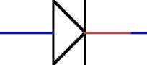Cathode

**P-N Junction Diodes:**

A diode is an electronics component made from a combination of a P-type and N-type semiconductor material, known as a p-n junction, with leads attached to the two ends. The most The lead attached to the n-type semiconductor is called the cathode. Thus, the cathode is the negative side of the diode. The positive side of the diode — that is, the lead attached to the ptype semiconductor — is called the anode.

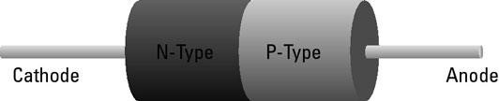

When a voltage source is connected to a diode such that the positive side of the voltage source is on the anode and the negative side is on the cathode, the diode becomes a conductor and allows current to flow. Voltage connected to the diode in this direction is called forward bias.

But if you reverse the voltage direction, applying the positive side to the cathode and the negative side to the anode, current doesn't flow. In effect, the diode becomes an insulator. Voltage connected to the diode in this direction is called reverse bias.

Forward bias allows current to flow through the diode. Reverse bias doesn't allow current to flow. (Up to a point, anyway. As you'll discover in just a few moments, there are limits to how much reverse bias voltage a diode can hold at bay.)

The anode is on the left, and the cathode is on the right. Here are two useful tricks for remembering which side of the symbol is the anode and which is the cathode.

**Rectifier diodes:**

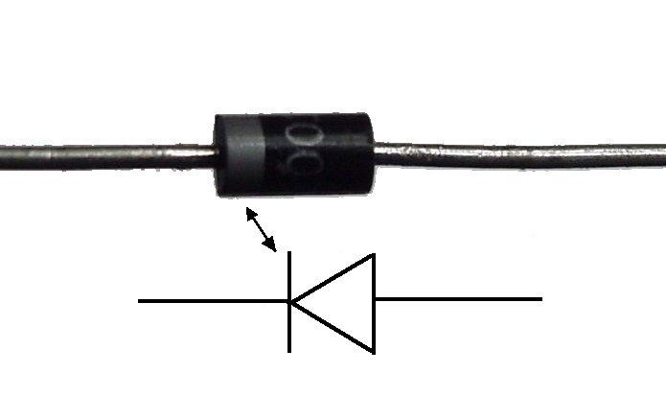

## Fig: Diode schematic symbol

A rectifier diode is designed specifically for circuits that need to convert alternating current to direct current. The most common rectifier diodes are identified by the model numbers 1N4001 through 1N4007. These diodes can pass currents of up to 1 A, and they have peak inverse voltage (PIV) ratings that range from 50 to 1,000 V.

Most rectifier diodes have a forward voltage drop of about 0.7 V. Thus, a minimum of 0.7 V is required for current to flow through the diode.

**Current–voltage characteristic:**

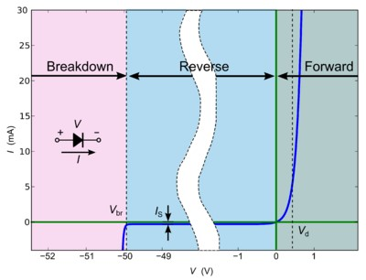

## Fig: I–V (current vs. voltage) characteristics of a p–n junction diode

A semiconductor diode's behavior in a circuit is given by its [current–voltage characteristic,](http://en.wikipedia.org/wiki/Current%E2%80%93voltage_characteristic) or I– V graph (see graph below). The shape of the curve is determined by the transport of charge carriers through the so-called [depletion layer](http://en.wikipedia.org/wiki/Depletion_zone) or [depletion region](http://en.wikipedia.org/wiki/Depletion_region) that exists at the [p–n junction](http://en.wikipedia.org/wiki/P%E2%80%93n_junction) between differing semiconductors. When a p–n junction is first created, conduction-band (mobile) electrons from the N[-doped](http://en.wikipedia.org/wiki/Dopant) region diffuse into the P[-doped](http://en.wikipedia.org/wiki/Dopant) region where there is a large population of holes (vacant places for electrons) with which the electrons "recombine". When a mobile electron recombines with a hole, both hole and electron vanish, leaving behind an immobile positively charged donor (dopant) on the N side and negatively charged acceptor (dopant) on the P side. The region around the p–n junction becomes depleted of [charge carriers](http://en.wikipedia.org/wiki/Charge_carrier) and thus behaves as an [insulator.](http://en.wikipedia.org/wiki/Nonconductor)

**2.7 Zener Diode (5.1V 400mW):**

A Zener diode is a diode which allows current to flow in the forward direction in the same manner as an ideal diode, but also permits it to flow in the reverse direction when the voltage is above a certain value known as the breakdown voltage, zener knee voltage, zener voltage, avalanche point, or peak inverse voltage.



## Zener Diode schematic symbol

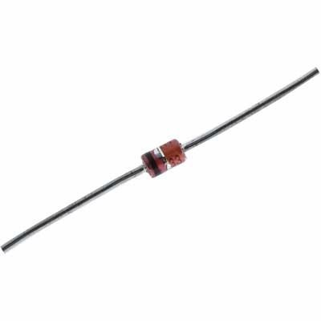

## Fig: Practical symbol of zener diode

**Operation:**

In a normal diode, the peak inverse voltage is usually pretty high — 50, 100, even 1,000 V. If the reverse voltage across the diode exceeds this number, current floods across the diode in the reverse direction in an avalanche, which usually results in the diode's demise. Normal diodes aren't designed to withstand a reverse avalanche of current. Zener diodes are. They're specially designed to withstand current that flows when the peak inverse voltage is reached or exceeded. And more than that, Zener diodes are designed so that as the reverse voltage applied to them exceeds the threshold voltage, current flows more and more in a way that holds the voltage drop across the diode at a fixed level. In other words, Zener diodes can be used to regulate the voltage across a circuit. In a Zener diode, the peak inverse voltage is called the Zener voltage. This voltage can be quite low — in the range of a few volts — or it can be hundreds of volts.

Zener diodes are often used in circuits where a predictable voltage is required. For example, suppose you have a circuit that will be damaged if you feed it with more than 5 V. In that case, you could place a 5 V Zener diode across the circuit, effectively limiting the circuit to 5 V. If more than 5 V is applied to the circuit, the Zener diode conducts the excess voltage away from the sensitive circuit

**2.8 Microcontroller PIC16F72:**

This document contains device specific information for the operation of the PIC16F72 device. Additional information may be found in the PIC™ Mid-Range MCU Reference Manual (DS33023), which may be downloaded from the Microchip website. The Reference Manual should be considered a complementary document to this data sheet, and is highly recommended reading for a better understanding of the device architecture and operation of the peripheral modules. The PIC16F72 belongs to the Mid-Range family of the PIC devices. A block diagram of the device is shown in Figure 1-1. The program memory contains 2K words, which translate to 2048 instructions, since each 14-bit program memory word is the same width as each device instruction. The data memory (RAM) contains 128 bytes. There are 22 I/O pins that are user configurable on a pin-to-pin basis. Some pins are multiplexed with other device functions. These functions include:

• External interrupt

• Change on PORTB interrupt

• Timer0 clock input

• Timer1 clock/oscillator

• Capture/Compare/PWM

• A/D converter

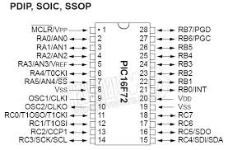

There are two memory blocks in the PIC16F72 device. These are the program memory and the data memory. Each block has separate buses so that concurrent access can occur. Program memory and data memory are explained in this section. Program memory can be read internally by the user code (see Section 7.0). The data memory can further be broken down into the general purpose RAM and the Special Function Registers (SFRs). The operation of the SFRs that control the “core” are described here. The SFRs used to control the peripheral modules are described in the section discussing each individual peripheral module. Additional information on device memory may be found in the PIC™ Mid-Range Reference Manual, (DS33023).

Reference: <http://ww1.microchip.com/downloads/en/DeviceDoc/39597C.pdf>

**2.9 Transistor:**

**BC547** is an NPN bi-polar junction transistor. A transistor, stands for transfer of resistance, is commonly used to amplify current. A small current at its base controls a larger current at collector & emitter terminals. **BC547** is mainly used for amplification and switching purposes. It has a maximum current gain of 800. Its equivalent transistors are BC548 and BC549.

The transistor terminals require a fixed DC voltage to operate in the desired region of its characteristic curves. This is known as the biasing. For amplification applications, the transistor is biased such that it is partly on for all input conditions. The input signal at base is amplified and taken at the emitter. BC547 is used in common emitter configuration for amplifiers. The voltage divider is the commonly used biasing mode. For switching applications, transistor is biased so that it remains fully on if there is a signal at its base. In the absence of base signal, it gets completely off.

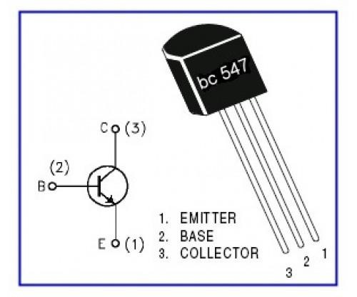

A bipolar junction transistor (BJT or bipolar transistor) is a type of [transistor](http://en.wikipedia.org/wiki/Transistor) that relies on the contact of two types of [semiconductor](http://en.wikipedia.org/wiki/Semiconductor) for its operation. BJTs can be used as [amplifiers,](http://en.wikipedia.org/wiki/Electronic_amplifier) switches, or in [oscillators.](http://en.wikipedia.org/wiki/Electronic_oscillator) BJTs can be found either as individual discrete components, or in large numbers as parts of [integrated circuits.](http://en.wikipedia.org/wiki/Integrated_circuit) Bipolar [transistors](http://en.wikipedia.org/wiki/Transistor) are so named because their operation involves both [electrons](http://en.wikipedia.org/wiki/Electron) and [holes.](http://en.wikipedia.org/wiki/Electron_hole) These two kinds of charge carriers are characteristic of the two kinds of [doped](http://en.wikipedia.org/wiki/Doping_%28semiconductor%29) [semiconductor](http://en.wikipedia.org/wiki/Semiconductor) material; electrons are majority charge carriers in ntype semiconductors, whereas holes are majority charge carriers in p-type semiconductors. In contrast, unipolar transistors such as the [field-effect transistors](http://en.wikipedia.org/wiki/Field-effect_transistor) have only one kind of charge carrier.

Charge flow in a BJT is due to [diffusion](http://en.wikipedia.org/wiki/Diffusion) of [charge carriers](http://en.wikipedia.org/wiki/Charge_carriers_in_semiconductors) across a junction between two regions of different charge concentrations. The regions of a BJT are called emitter, collector, and base. A discrete transistor has three leads for connection to these regions. Typically, the emitter region is heavily doped compared to the other two layers, whereas the majority charge carrier concentrations in base and collector layers are about the same. By design, most of the BJT collector current is due to the flow of charges injected from a high-concentration emitter into the base where there are [minority carriers](http://en.wikipedia.org/wiki/Minority_carrier) that diffuse toward the collector, and so BJTs are classified as minority-carrier devices.

**Transistor parameters: Alpha (α) and Beta (β):**

The proportion of electrons able to cross the base and reach the collector is a measure of the BJT efficiency. The heavy doping of the emitter region and light doping of the base region causes many more electrons to be injected from the emitter into the base than holes to be injected from the base into the emitter. The [common-emitter](http://en.wikipedia.org/wiki/Common-emitter) current gain is represented by βF or hFE; it is approximately the ratio of the DC collector current to the DC base current in forward-active region. It is typically greater than 100 for small-signal transistors but can be smaller in transistors designed for high-power applications. Another important parameter is the [commonbase](http://en.wikipedia.org/wiki/Common-base) current *gain*, αF. The common-base current gain is approximately the gain of current from emitter to collector in the forward-active region. This ratio usually has a value close to unity; between 0.98 and 0.998. It is less than unity due to [recombination of charge carriers](http://en.wikipedia.org/wiki/Carrier_generation_and_recombination) as they cross the base region. Alpha and beta are more precisely related by the following identities (NPN transistor):



**Structure:**

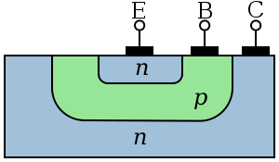

## Fig: Simplified cross section of a planar NPN bipolar junction transistor

A BJT consists of three differently [doped](http://en.wikipedia.org/wiki/Doping_%28semiconductor%29) semiconductor regions, the emitter region, the base region and the collector region. These regions are, respectively, p type, n type and p type in a PNP transistor, and n type, p type and n type in an NPN transistor. Each semiconductor region is connected to a terminal, appropriately labeled: emitter (E), base (B) and collector (C). The base is physically located between the emitter and the collector and is made from lightly doped, high resistivity material. The collector surrounds the emitter region, making it almost impossible for the electrons injected into the base region to escape without being collected, thus making the resulting value of α very close to unity, and so, giving the transistor a large β. A cross section view of a BJT indicates that the collector–base junction has a much larger area than the emitter– base junction.

The bipolar junction transistor, unlike other transistors, is usually not a symmetrical device. This means that interchanging the collector and the emitter makes the transistor leave the forward active mode and start to operate in reverse mode. Because the transistor's internal structure is usually optimized for forward-mode operation, interchanging the collector and the emitter makes the values of α and β in reverse operation much smaller than those in forward operation; often the α of the reverse mode is lower than 0.5. The lack of symmetry is primarily due to the doping ratios of the emitter and the collector. The emitter is heavily doped, while the collector is lightly doped, allowing a large reverse bias voltage to be applied before the collector–base junction breaks down. The collector–base junction is reverse biased in normal operation. The reason the emitter is heavily doped is to increase the emitter injection efficiency: the ratio of carriers injected by the emitter to those injected by the base. For high current gain, most of the carriers injected into the emitter–base junction must come from the emitter.

**Regions of operation:**

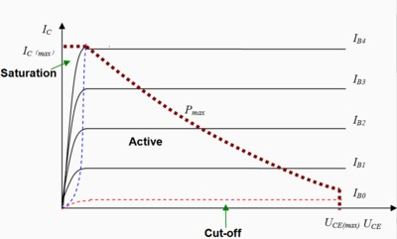

Fig: The relationship between .

,

and



**Forward-active** (or simply, **active**): The base–emitter junction is forward biased and the base–collector junction is reverse biased. Most bipolar transistors are designed to afford the greatest common-emitter current gain, βF, in forward-active mode. If this is the case, the collector–emitter current is approximately [proportional](http://en.wikipedia.org/wiki/Proportionality_%28mathematics%29) to the base current, but many times larger, for small base current variations.

**Reverse-active** (or **inverse-active** or **inverted**): By reversing the biasing conditions of the forward-active region, a bipolar transistor goes into reverse-active mode. In this mode, the emitter and collector regions switch roles. Because most BJTs are designed to maximize current gain in forward-active mode, the βF in inverted mode is several times smaller (2–3 times for the ordinary germanium transistor). This transistor mode is seldom used, usually being considered only for failsafe conditions and some types of bipolar logic. The reverse bias breakdown voltage to the base may be an order of magnitude lower in this region.

**Saturation**: With both junctions forward-biased, a BJT is in saturation mode and facilitates high current conduction from the emitter to the collector (or the other direction in the case of NPN, with negatively charged carriers flowing from emitter to collector).

This mode corresponds to a logical "on", or a closed switch.

**Cutoff**: In cutoff, biasing conditions opposite of saturation (both junctions reverse biased) are present. There is very little current, which corresponds to a logical "off", or an open switch.

**2.10 Relay:**

A **relay** is an [electrically](http://en.wikipedia.org/wiki/Electric) operated [switch.](http://en.wikipedia.org/wiki/Switch) Many relays use an [electromagnet](http://en.wikipedia.org/wiki/Electromagnet) to mechanically operate a switch, but other operating principles are also used, such as [solid-state relays.](http://en.wikipedia.org/wiki/Solid-state_relay) Relays are used where it is necessary to control a circuit by a low-power signal (with complete electrical isolation between control and controlled circuits), or where several circuits must be controlled by one signal. The first relays were used in long distance [telegraph](http://en.wikipedia.org/wiki/Electrical_telegraph) circuits as amplifiers: they repeated the signal coming in from one circuit and re-transmitted it on another circuit. Relays were used extensively in telephone exchanges and early computers to perform logical operations.

A type of relay that can handle the high power required to directly control an electric motor or other loads is called a [contactor.](http://en.wikipedia.org/wiki/Contactor) [Solid-state relays](http://en.wikipedia.org/wiki/Solid-state_relay) control power circuits with no [moving parts,](http://en.wikipedia.org/wiki/Moving_parts) instead using a semiconductor device to perform switching. Relays with calibrated operating characteristics and sometimes multiple operating coils are used to protect electrical circuits from overload or faults; in modern electric power systems these functions are performed by digital instruments still called "[protective relays"](http://en.wikipedia.org/wiki/Protective_relay).

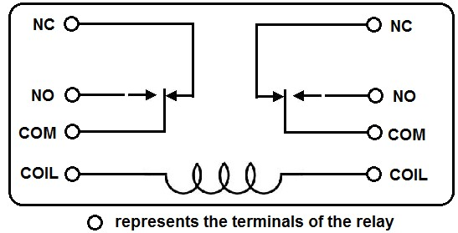

Relays in a control panel. Although such relays once were the backbone of automation in such industries as automobile assembly, the [programmable logic controller](http://en.wikipedia.org/wiki/Programmable_logic_controller) (PLC) mostly displaced the machine tool relay from sequential control applications. A relay allows circuits to be switched by electrical equipment: for example, a timer circuit with a relay could switch power at a preset time. For many years relays were the standard method of controlling industrial electronic systems. A number of relays could be used together to carry out complex functions [(relay logic)](http://en.wikipedia.org/wiki/Relay_logic). The principle of relay logic is based on relays which energize and de-energize associated contacts. Relay logic is the predecessor of [ladder logic,](http://en.wikipedia.org/wiki/Ladder_logic) which is commonly used in [programmable logic controllers.](http://en.wikipedia.org/wiki/Programmable_logic_controller)

**Pole and Throw:**

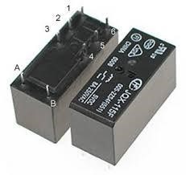

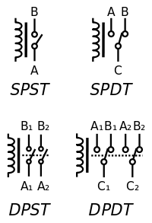

Circuit symbols of relays. (C denotes the common terminal in SPDT and DPDT types.) Since relays are [switches,](http://en.wikipedia.org/wiki/Switch) the terminology applied to switches is also applied to relays; a relay switches one or more poles, each of whose contacts can be thrown by energizing the coil in one of three ways:

* Normally-open (**NO**) contacts connect the circuit when the relay is activated; the circuit is disconnected when the relay is inactive. It is also called a **Form A** contact or "make" contact. **NO** contacts may also be distinguished as "early-make" or **NOEM**, which means that the contacts close before the button or switch is fully engaged.
* Normally-closed (**NC**) contacts disconnect the circuit when the relay is activated; the circuit is connected when the relay is inactive. It is also called a **Form B** contact or "break" contact. **NC** contacts may also be distinguished as "late-break" or **NCLB**, which means that the contacts stay closed until the button or switch is fully disengaged.
* Change-over (**CO**), or double-throw (**DT**), contacts control two circuits: one normally-open contact and one normally-closed contact with a common terminal. It is also called a **Form C** contact or "transfer" contact ("break before make"). If this type of contact utilizes a "make before break" functionality, then it is called a **Form D** contact.

**The following designations are commonly encountered:**

* **SPST** – Single Pole Single Throw. These have two terminals which can be connected or disconnected. Including two for the coil, such a relay has four terminals in total. It is ambiguous whether the pole is normally open or normally closed. The terminology "SPNO" and "SPNC" is sometimes used to resolve the ambiguity.
* **SPDT** – Single Pole Double Throw. A common terminal connects to either of two others. Including two for the coil, such a relay has five terminals in total.
* **DPST** – Double Pole Single Throw. These have two pairs of terminals. Equivalent to two SPST switches or relays actuated by a single coil. Including two for the coil, such a relay has six terminals in total. The poles may be Form A or Form B (or one of each).
* **DPDT** – Double Pole Double Throw. These have two rows of change-over terminals. Equivalent to two SPDT switches or relays actuated by a single coil. Such a relay has eight terminals, including the coil.

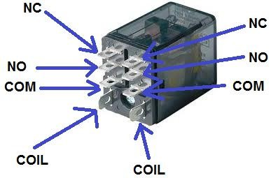

**Applications:**

* Amplifying a digital signal, switching a large amount of power with a small operating power. Some special cases are:
  + A telegraph relay, repeating a weak signal received at the end of a long wire o Controlling a high-voltage circuit with a low-voltage signal, as in some types of [modems](http://en.wikipedia.org/wiki/Modem) or audio amplifiers,
  + Controlling a high[-current](http://en.wikipedia.org/wiki/Electric_current) circuit with a low-current signal, as in the [starter](http://en.wikipedia.org/wiki/Starter_motor) [solenoid](http://en.wikipedia.org/wiki/Solenoid) of an [automobile,](http://en.wikipedia.org/wiki/Automobile)
* Detecting and isolating faults on transmission and distribution lines by opening and closing [circuit breakers](http://en.wikipedia.org/wiki/Circuit_breaker) (protection relays),
* Isolating the controlling circuit from the controlled circuit when the two are at different potentials, for example when controlling a mains-powered device from a low-voltage switch. The latter is often applied to control office lighting as the low voltage wires are easily installed in partitions, which may be often moved as needs change. They may also be controlled by room occupancy detectors to conserve energy, Logic functions. For example, the Boolean AND function is realized by connecting normally open relay contacts in series, the OR function by connecting normally open contacts in parallel. The change-over or Form C contacts perform the XOR (exclusive or) function. Similar functions for NAND and NOR are accomplished using normally closed contacts. The [Ladder programming language](http://en.wikipedia.org/wiki/Ladder_programming_language) is often used for designing [relay logic](http://en.wikipedia.org/wiki/Relay_logic) networks.

**2.11 LCD 1602A**

Display Mode: STN, BLUB y

Display Formate: 16 Character x 2 Line y

Viewing Direction: 6 O’Clock y Input

Data: 4-Bits or 8-Bits interface available y

Display Font : 5 x 8 Dots y

Power Supply : Single Power Supply (5V±10%) y

Driving Scheme : 1/16Duty,1/5Bias y

BACKLIGHT（SIDE）：LED（WHITE） 2.0

The display has an LED backlight and can display two rows with up to 16 characters on each row. You can see the rectangles for each character on the display and the pixels that make up each character. The display is just white on blue and is intended for showing text.

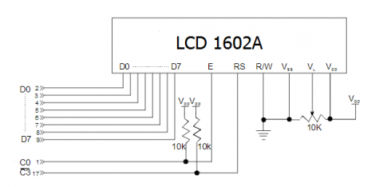

# Chapter 3 Circuit and Operation

**3.1 How the Circuit Functions:**

A voltage protection system is a device which is used to sense inappropriate voltage levels and correct them to produce a reasonably stable output at the output where the load is connected. Here we will study the design of a simple automatic mains AC voltage protection system which can be applied for the above purpose. Referring to the figure we find that the whole circuit is configured with the single microcontroller PIC16F72. It becomes the control section of the whole design.

The IC is wired as a comparator, we all know how well this mode suits the PIC16F72 and other microcontrollers. It's two inputs are suitable rigged for the said operations.

Pin #2 of the IC is clamped to a reference level, created by the resistor R1 and the zener diode, while pin #3 is applied with the sample voltage from the transformer or the supply source. This voltage becomes the sensing voltage for the IC and is directly proportional to the varying AC input of our mains supply.

The preset is used to set the triggering point or the threshold point at which the voltage may be assumed to be dangerous or inappropriate. We will discuss this in the setting up procedure section.

The pin #6 which is the output of the IC, goes high as soon as pin #3 reaches the set point and activates the transistor/relay stage.

In case the mains voltage crosses a predetermined threshold, the ICs non inverting detects it and its output immediately goes high, switching ON the transistor and the relay for the desired actions.

The relay, which is a DPDT type of relay, has its contacts wired up to a transformer, which is an ordinary transformer modified to perform the function of a protection system transformer.

It’s primary and secondary windings are interconnected in such a manner that through appropriate switching of its taps, the transformer is able to add or deduct a certain magnitude of AC mains voltage and produce the resultant to the output connected load.

The relay contacts are appropriately integrated to the transformer taps for executing the above actions as per the commands given by the microcontroller output.

So if the input AC voltage tends to increase a set threshold value, the transformer deducts some voltage and tries to stop the voltage from reaching dangerous levels and vice versa during low voltage situations.

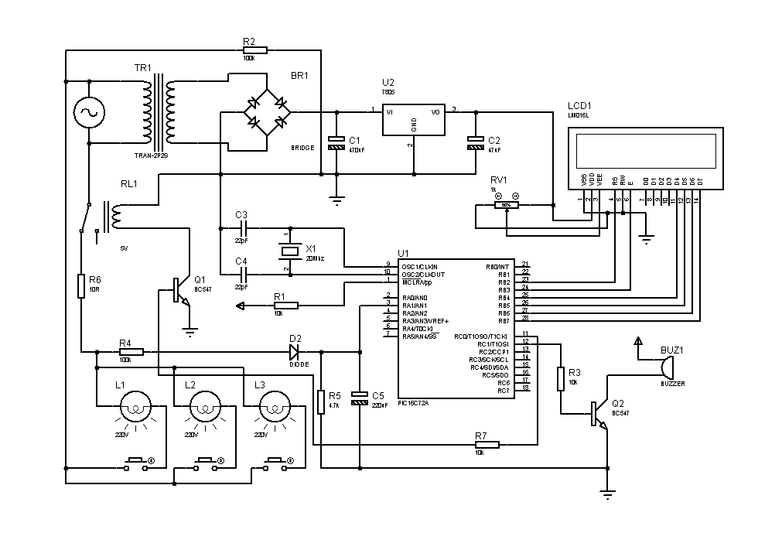**3.2 Circuit Diagram:**

**Fig: Circuit diagram of voltage protection system.**

**Operation:**

The proposed simple automatic voltage protection system circuit may be set up with the following steps: Initially do not connect the transformers to the circuit. Using a variable power supply, power the circuit across C1, the positive goes to the terminal of R1 while the negative goes to the line of D2’s cathode. Set the voltage to about 12.5 voltage and adjust the preset so that the output of the IC just becomes high and triggers the relay. Now lowering the voltage to about 12 volts should make the microcontroller trip the relay to its original state or make it de-energized. Repeat and check the relay action by altering the voltage from 12 to 13 volts, which should make the relay flip flop correspondingly. Your setting up procedure is over. Now you may connect both the transformer to its appropriate positions with the circuit. Our simple home made mains voltage protection system circuit is ready. When installed, the relay trips whenever the input voltage crosses 230 volts, bringing the output to 218 volts and keeps this distance continuously as the voltage reaches higher levels. When the voltage drops back to 225, the relay gets de-energized pulling the voltage to 238 volts and maintains the difference as the voltage further goes down. The above action keeps the output to the appliance well between 200 to 250 volts with fluctuations ranging from 180 to 265 volts.

# Chapter 4 Discussion and Conclusion

**4.1 Utilities:**

* Over-voltage protection
* Under-voltage protection
* Protection against transients
* High reliability
* High performance
* Low cost
* protection to load from frequent turning ON & OFF by providing time delay. Under-voltage relay, in case the mains voltage starts fluctuating in the vicinity of under or over voltage preset points.
* It can be used to protect loads such as refrigerator , T.V and VCR from undesirable over and under line voltages.

**4.2 Limitation:**

* + - When installed, the relay trips whenever the input voltage crosses 230 volts, bringing the output to 218 volts and keeps this distance continuously as the voltage reaches higher levels.

* + - When the voltage drops back to 225, the relay gets de-energized pulling the voltage to 238 volts and maintains the difference as the voltage further goes down.

* + - The above action keeps the output to the appliance well between 200 to 250 volts with fluctuations ranging from 180 to 265 volts.

**4.3 Conclusion:**

It is an inexpensive automatic voltage protection system circuit, which is fabricated using transistors and other discrete components. It can be used to protect loads such as refrigerator, TV and VCR from undesirable over and under line voltages, as well as surges caused due to sudden failure/ resumption of mains power supply. A voltage protection system is a device which is used to sense inappropriate voltage levels and correct them to produce a reasonably stable output at the output where the load is connected. Here we will study the design of a simple automatic mains AC voltage protection system which can be applied for the above purpose. Referring to the figure we find that the whole circuit is configured with the single microcontroller PIC16F72. It becomes the control section of the whole design. The IC is wired as a comparator, we all know how well this mode suits the PIC16F72 and other microcontrollers. It's two inputs are suitable rigged for the said operations. Referring to the figure we find that the whole circuit is configured with the single microcontroller PIC16F72. It becomes the control section of the whole design. The IC is wired as a comparator, we all know how well this mode suits the PIC16F72 and other microcontrollers. It's two inputs are suitable rigged for the said operations. Now you may connect both the transformer to its appropriate positions with the circuit.Our simple voltage protection system circuit is ready.

First start with great thank to almighty, we take this opportunity to express our profound gratitude and deep regards to our guide Ashraful Arefin for his exemplary guidance, monitoring and constant encouragement throughout the course of this project. I can’t say thank you enough for his tremendous support and help. I feel motivated and encouraged every time we attend his meeting. Without his encouragement and guidance this project would not have materialized. We sincerely thank the respected teachers and faculty members of Northern University Bangladesh as they have tremendous contribution behind our progress. Last but not least we wish to avail ourselves of this opportunity, express a sense of gratitude and love to our friends and our beloved parents for their manual support, strength and help and for everything.

**References:**

* + 1. <http://www.diy-electronic-projects.com/p183-High-and-low-voltage-cut-off-with-time-delay>
    2. [http://electronicseverywhere.blogspot.com/2010/11/overunder-voltage-cut-off-with-ontime.html](http://electronicseverywhere.blogspot.com/2010/11/overunder-voltage-cut-off-with-on-time.html)
    3. <http://en.wikipedia.org/wiki/>
    4. <http://www.dummies.com/how-to/content/electronics-components-diodes.html>

5.

[http://books.google.com.bd/books?id=NunPn6rRTAC&pg=PA81&dq=diode+cathode+anode+n -type&rediresc=y#v=onepage&q=diode%20cathode%20n-type&f=false](http://books.google.com.bd/books?id=NunPn6rRTAC&pg=PA81&dq=diode+cathode+anode+n-type&rediresc=y#v=onepage&q=diode%20cathode%20n-type&f=false)

* + 1. <http://www.eleinmec.com/article.asp?1>
    2. <http://www.daycounter.com/Calculators/NE555-Calculator.phtml>
    3. <http://www.gedigitalenergy.com/multilin/notes/artsci/>
    4. [http://books.google.com.bd/books?id=5RkbwbYq1joC&pg=PA58&dq=silver-](http://books.google.com.bd/books?id=5RkbwbYq1joC&pg=PA58&dq=silver-oxide+relay+contact&redir_esc=y#v=onepage&q=silver-oxide%20relay%20contact&f=false)

[oxide+relay+contact&redir_esc=y#v=onepage&q=silver-oxide%20relay%20contact&f=false](http://books.google.com.bd/books?id=5RkbwbYq1joC&pg=PA58&dq=silver-oxide+relay+contact&redir_esc=y#v=onepage&q=silver-oxide%20relay%20contact&f=false)

* + 1. <http://www.todaysengineer.org/2003/May/history.asp>

11.[http://www.google.com/patents?id=uBFMAAAAEBAJ&printsec=abstract#v=onepage&q&f](http://www.google.com/patents?id=uBFMAAAAEBAJ&printsec=abstract" \l "v=onepage&q&f=false)

[=false](http://www.google.com/patents?id=uBFMAAAAEBAJ&printsec=abstract#v=onepage&q&f=false)

12.

[http://www.ieeeghn.org/wiki/index.php/Milestones:Invention_of_the_first_Transistor_at_Bell_T elephone_laboratories,_Inc.,_1947](http://www.ieeeghn.org/wiki/index.php/Milestones:Invention_of_the_first_Transistor_at_Bell_Telephone_laboratories,_Inc.,_1947)

13. <http://spectrum.ieee.org/energy/renewables/winner-super-cahrged>